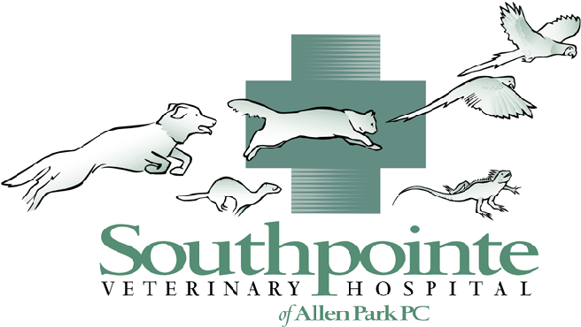
Information about your pet’s surgery

(313) 381-7180

Thank you for recognizing the need to spay or neuter your pet. Many people shop around for the best price on this surgery without knowing why the cost varies among practices. This guide will help you find the best fit between the hospital’s procedures and expectations for your pet’s care and safety.

WHAT YOU SHOULD ASK – AND WHY

1 Will my pet receive a complete physical exam before surgery?
An animal that suffers from such disorders as a parasite infection, an infectious disease, or a heart murmur shouldn’t undergo surgery. A presurgery exam is our chance to detect these conditions. Age-appropriate bloodwork also reveals problems that aren’t obvious.

2 What safety precautions will you take during surgery?
While most surgery is uneventful, emergencies sometimes occur. Detecting problems early improves our ability to intervene and correct them. We will begin in our sterile surgical suite. We will place a breathing tube in all anesthetized animals to keep the airway open and allow for supplemental oxygen or gas anesthesia as needed. A monitor allows the surgeon to track heart rate and rhythm as well as the amount of oxygen in the blood to ensure respiration and circulation are normal. Along with the doctor, a Licensed Veterinary Technician (LVT) monitors your pet throughout the surgery. In addition, some patients receive IV fluids during surgery to support circulation. The practice also keeps a crash box with emergency drugs and supplies handy.

3 What safety precautions will you take after surgery?
Surgery patients lose body heat through anesthesia and the opening of body cavities. If a patient gets too cold, the heart can be affected. A Licensed Veterinary Technician (LVT) will monitor patient temperature at regular intervals during and after surgery and provide supplemental heating as needed. We also monitor your pet’s gum color, pulse, and respiration to ensure that respiration and circulation are normal.

4 How will you manage my pet’s pain?
Surgery hurts! The anesthetic won’t provide pain control once the pet wakes up, so in addition to analgesics provided during surgery, we routinely give post operative pain control medication.

5 Will I receive written post surgical care instructions?
Follow-up care is crucial for proper healing. A doctor or Licensed Veterinary Technician will discuss your pet’s postoperative care; provide clear, written discharge instructions; and ask whether you have any questions.

